II.WILDCATS IN THE RING

INVITATION
Reason of the competition:
We have a great pleasure to invite all female boxers and the officials of your club to have a great competition opportunity with international teams. The participants can be from all age groups in female boxing. We would like to popularize the box as a sport activity in our area with this event.
Dates:
22rd-23th-24th June 2017. (Thursday-Friday-Saturday)
Place of the Event:
2314 Halásztelek, Ősz u. 1 (Hungary)(City Sport Hall)
Weight-in and medical examination: (Place: at the competition venue)
Weight-in and medical examination: 22rd June 2017., 8:00-11:00
23th June 2017., 8:00-9:00
Medical examination (only): 24th June 2017., 8:00-8:30
Technical meeting and official draw:
22rd June 2017 at 12:00 Place: at the competition venue
Time of the bouts:
22rd June 2017 from 15:00
23th June 2017 from 15:00
24th June 2017. from 9:00
Director of the Competition:
Box Club of Halásztelek and Boxing Regional Centre of Pest County
Judges will be appointed by the Judge Committee of the Hungarian Boxing Association. Each international club can bring a referee and a judge. Each of them must have a Record Card.
Groups: All women age groups and weight groups.
Category | Age / Date of Birth | Weight category
School girls I. | 11-12 yrs / 2005-2006 | 34 kg, 36 kg, 38 kg, 40 kg, 42 kg, 44 kg, 46 kg, 48 kg, 50 kg, 52 kg, 54 kg, 57 kg, 60 kg, 63 kg, 66 kg, 70 kg, 70+kg
School girls II. | 13-14 yrs / 2003-2004 | 38 kg, 40 kg, 42 kg, 44 kg, 46 kg, 48 kg, 50 kg, 52 kg, 54 kg, 57 kg, 60 kg, 63 kg, 66 kg, 70 kg, 75 kg, 75+kg
Juniors | 15-16 yrs / 2001-2002 | 44-46, 48, 50, 52, 54, 57, 60, 63, 66, 70 75 80 +80kg
Youth | 17-18 yrs / 1999-2000 | 45-48, 51, 54, 57, 60, 64, 69, 75, 81, +81kg
Elite | 19-40 yrs / 1977-1998 | 45-48, 51, 54, 57, 60, 64, 69, 75, 81, +81kg

Rules:
Weight groups can be integrated if all coaches agree. Each boxer must have a medical certificate (not older than 6 months) in all age groups, except in elite category they must have a medical certificate (not older than 1 year). According to the Competition Law each boxer must have a competition licence and a sport insurance card.
All competitors must wear a gum-shield (all colours except red) and a face-guard according to the colour of their corner (red or blue), underneath they must wear a swimming cap or head scarf, shorts or skirts, sport jersey, gloves with bandadge in the same colour and high top boxing shoes.
All competitors must fill out and sign the attached pregnancy statement and give it to the organization committee at the time of registration. If under 18, the competitor’s statement must be signed by any of the guardians.
If there is only one personnel in a weight group, they can participate in a sparing during the event on each day (12:30-14:00) with judges during the match.
It is possible to organize training matches for non-weight-in and non-paired-up boxers before the competition (11:00-12:30) with the coordination and agreement of their coaches and associations without judges.
Duration of the rounds in categories:
School girls I. 3x1 minute
School girls II. 3x1,5 minutes
Junior 3x2 minutes
Youth 3x3 minutes
Elite 3x3 minutes
Awards:
The final bouts will be awarded with gold and silver medal. The best boxers will get special awards decided by the President of the Judges and the presented professional leaders of the Hungarian Box Association.
Costs: No registration fee will apply.
Each participants must cover their travel, accommodation and all other costs.
Miscellaneous:
The Box Club of Halásztelek is not responsible for any lost or damaged property during the event.
All other questions which is not stated in the above invitation, the general competition rules apply.
We reserve the right to change the program of the competition.
All competitor must have and AIBA competition certificate, a valid medical certificate and a sport insurance card. All coach must have their coach ID with them and they must show it to the jury up on request.
Registration: as soon as possible, latest 5 June 2017.
Registrations must be sent to wildcatsring2017@gmail.com on the separate registration sheet.
IMPORTANT! Each boxer must have a valid medical certificate and AIBA record book.
If you have any questions, please do not hesitate to contact us
E-mail: wildcatsring2017@gmail.com

6th April 2017, Halásztelek
Barnabás Csipkés
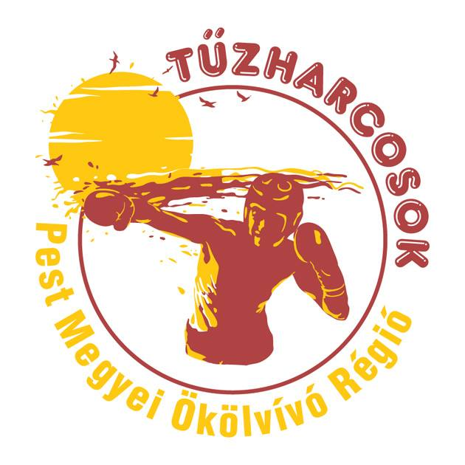

Box Club of Halásztelek
President

Accomodations:

